**A**

**PROJECT REPORT**

**ON**

**GRIP AUTO SPARES**

**Submitted By**

**ANKIT.V.SHETTY**

APRIL-2017

**UNDER THE GUIDANCE OF**

**PROF.GAYATRI BAKHTIANI**

**SUBMITTED IN PARTIAL FULFILLMENT OF ACADEMIC PROJECT**

**[Bachelors of Science Computer Science]**



**UNIVERSITY OF MUMBAI**

SHREE SHANKAR NARAYAN EDUCATION TRUSTS SHANKAR NARAYAN COLLEGE

(DEPARTMENT OF BSC-CS)

**ACKNOWLEDGEMENT**

This project could not have been accomplished if not for the direct or indirect contribution from many known and unknown individuals. We wish to take this opportunity to express our gratitude to all of them.

I would also like to thank Grip Auto Spares for Giving us this opportunity to work on a project for them.

I express my gratitude towards our internal guide

**Miss. GAYATRI BAKHTIANI** who gave us unending support from the stage the Project was initiated. A source of inspiration, given by them constantly kept our spirits high whenever we were dispirited.

I would also like to thank our **H.O.D** **Miss. SMITA DALVI**.  
The foundation that we have been able to develop today owes much credit to her. Always ready to cooperate, she has been very kind in guiding us how to go about developing the project.

A Very Special Thanks to **Miss. DEEPA GURSALE** for her cooperation in helping with my project.

I would even like to thank all our friends for their co-operation and help in my project.

Above all I would like to thank first, the almighty who have given us inspiration & courage to accept it as a course of life.

**ANKIT.V.SHETTY**

**INDEX**

**INDEX**

|  |  |  |  |
| --- | --- | --- | --- |
| **NO:** | **CONTENTS** | | **PAGE** |
| **PRELIMINARY INVESTIGATION:** | | | |
| **1.1** | **ORGANIZATION OVERVIEW** | | **6** |
| **1.2** | **CURRENT SYSTEM** | | **6** |
| **1.3** | **LIMITATION OF CURRENT SYSTEM** | | **7** |
| **1.4** | **PROPOSED SYSTEM AND ITS ADVANTAGES** | | **8** |
| **1.5** | **FEASIBILITY STUDY** | | **8** |
| **1.6** | **GANTT CHART** | | **14** |
| **SYSTEM ANALYSIS:** | | | |
| **2.1** | **FACT FINDING TECHNIQUES** | | **17** |
| **2.2** | **EVENT TABLE** | | **20** |
| **2.3** | **USE-CASE DIAGRAM** | | **22** |
| **2.4** | **SCENARO AND USE-CASE DESCRIPTION** | | **23** |
| **2.5** | **E-R DIAGRAM** | | **24** |
| **2.6** | **ACTIVITY DIAGRAM** | | **26** |
| **2.7** | **CLASS DIAGRAM** | | **28** |
| **2.8** | **SEQUENCE DIAGRAM** | | **30** |
| **2.9** | **STATE DIAGRAM** | | **33** |
| **SYSTEM DESIGN:** | | | |
| **3.1** | **COMPONENT DIAGRAM** | | **38** |
| **3.2** | **DEPLOYMENT DIAGRAM** | | **40** |
| **3.3** | **STRUCTURE CHART (PROGRAM LEVEL & SYSTEM LEVEL)** | | **42** |
| **SYSTEM CODING:** | | | |
| **4.1** | **MENU TREE / SITE MAP** | | **45** |
| **4.2** | **LIST OF TABLES WITH ATTRIBUTES AND CONSTRAINTS** | | **47** |
| **4.3** | **PROGRAM DESCRIPTION** | | **52** |
| **4.4** | **VALIDATIONS** | | **53** |
| **4.5** | **TEST CASES, TEST DATA, TEST RESULTS** | | **55** |
| **4.6** | **SCREEN LAYOUTS & REPORT LAYOUTS** | | **55** |
| **MAINTENANCES AND EVALUTION:** | | | |
| **5.1** | | **SYSTEM IMPLEMENTATION** | **74** |
| **5.2** | **FUTURE ENHANCEMENTS** | | **76** |
| **5.3** | **REFERENCES AND BIBLIOGRAPHY** | | **78** |

Preliminary Investigation

**ORGANIZATION OVERVIEW**

**NAME OF COMPANY:**  **Grip Auto Spares**

**ADDRESS: -** 9/402,Kenwood Park,Ramdev Park Road,Miraroad(EAST)

**Mob: 8898952999**

**BELIEF: -**They believe in customer satisfactions and offer quality service to their customer

**INPUT SOURCE: -**.

This project is basically a Grip Auto Spares Desktop application which manages the data entry.

Grip Auto Spares is the Manufacturer of Automobile Precision Components and Fasteners Items Such as Circlips, E Clips, Dowel pins, Washers, springs, Keys, Locknuts, etc.

Each bill will have a unique number generated by the system automatically.

This system will also include the name, address and mobile number.

System will also help the vendor to keep track of number of products available, time of purchase.

It will also display other details such as last time when it is purchased, at what price it was purchased, from where it is purchased, total number of products which was purchased last time.

IT Save time in finding particular product and their price and making billing process faster. Eliminating manual searching for the products which will be stock. Easy process of adding and deleting products entry.

**Description Of System**

This system is based upon Sales and Purchase of Computer Parts

Following are its best characteristics.

|  |  |
| --- | --- |
| **1.** | Easily Understandable Relational Database. In SQL. |
| **2.** | Attractive Graphical User Interface. |
| **3.** | Maximum Security with Complete Validation. |
| **4.** | Highly Compatible and Easy to Use. |
| **5.** | Acquires Less Space. |
| **6.** | Bug Free. |

**Limitations Of Present System**

The system was first made in the DOS

This system has a lot of limitations compared to the latest.

Some of them are described below.

|  |  |
| --- | --- |
| **1.** | No Graphical User Interface |
| **2.** | No security. |
| **3.** | Maximum Errors. |
| **4.** | User have to learn this language to use this system |
| **5.** | User can Interact only using the Keyboard |

**Proposed System**

**Scope**

* System should be efficient and user friendly.
* System must be secured.
* System should generate reports.
* System should be fast.

**Advantages**

* This system was developed mainly under the condition to be used by any non technical user.

**Feasibility Study**

**Financial Feasibility**

* Total estimated cost of the project
* Financing of the project in terms of its capital structure, debt equity ratio and promoter's share of total cost
* Existing investment by the promoter in any other business
* Projected cash flow and profitability

**Technical Feasibility**

* **Software used for the development**
* **Back End :** MS. SQL Server 2008 R2
* **Front End :** Visual Studio 2010
* **Hardware Requirements**
* 256 MB Ram
* 1GB HD
* **System Requirements**
* .Net Framework (Latest)
* MS. Sql Server (Latest)

**PROTOTYPES**

**Process Model**

The simplest process model is the waterfall model, which states the Phases are organized in the linear order. The model was originally proposed by Royce, though variations of the model have evolved depending on the nature of activities and the flow of control between them. In this model, a project begins with feasibility analysis.

**Steps:-**

* Project Planning Phase
* Analysis Phase
* Design Phase(architecture, system, detailed)
* Coding Phase
* Testing Phase
* Software manuals (e.g. – user, installation, etc.)

**Project Planning Phase**

**Design Phase**

**Analysis Phase**

**Coding Phase**

**Testing Phase**

**Implementation Phase**

**Activity Sheet**

**SHANKAR NARAYAN COLLEGE**

**DEPARTMENT OF BSc (CS)**

**Semester VI Project Work Activity Sheet**

1. **Name of Student : ANKIT SHETTY**
2. **Project Title : Grip Auto Spares**
3. **Project Guide : Prof. GAYATRI BAKHTIANI**

|  |  |  |  |  |  |  |
| --- | --- | --- | --- | --- | --- | --- |
| **Sr.**  **No.** | **Activity** | **Planned** | | **Actual** | | **Sign** |
| **Start Date** | **End Date** | **Start Date** | **End Date** |
| 1. | Preliminary  Investigation |  |  |  |  |  |
| 2. | System Study and Analysis |  |  |  |  |  |
| 3. | System Development |  |  |  |  |  |
| 4. | System Coding and Report |  |  |  |  |  |
| 5. | Project  Submission |  |  |  |  |  |

**GANTT CHART**

**Gantt Chart**

|  |  |  |  |  |  |  |
| --- | --- | --- | --- | --- | --- | --- |
| **Month**  **Process** | **NOV**  **2016** | | **DEC**  **2016** | **JAN**  **2017** | **FEB**  **2017** | **MAR**  **2017** |
| **Preliminary**  **Investigation** |  |  | |  |  |  |
| **System**  **Analysis** |  |  | |  |  |  |
| **System Design** |  |  | |  |  |  |
| **System**  **Coding** |  |  | |  |  |  |
| **Maintenance & Evaluation** |  |  | |  |  |  |
| **Project**  **Submissions** |  |  | |  |  |  |

**- Planned Date**

**- Actual Date**

**System Analysis**

FACT FINDING TECHNIQUE

We mainly used three fact finding techniques to find out for ourselves the correct information on the basis of which we will build the software.

These fact finding techniques are extremely important because these are the facts on the basis of which we can build the software that comprises of a friendly environment for the customer to work with.

This is the reason why fact finding is an important activity.

The techniques which were used by me include:

1. Observation

2. Interview & Questionnaire

1.Observation:  
As per the observation number of people working in the Medical Shop are 2 to 3 and all the records maintained are in manual and the nature of business is generally is to sell medicines and general products based so the manual maintenance of records is not efficient to manage the work load so there is a need to introduce a software based system for fast and better work.

2. Questionnaire

Based on the System concept developed, a set of questionnaire was developed to eliminate all possible doubts regarding the requirements of the customer and development of the system. It is important to get answers to some important questions before proceeding to the actual design process. Following are the few questions comprising of the questionnaire.

* Are there any limitation bounding the system?
* What is the main use of system?
* What is the number of users of the system?
* Is there any recommended tool be used for the software development?
* Who are all the end users of the system?
* What is the recommended front –end ?
* What is the recommended back-end?
* What is the time limit for the development of the system.
* Is there any recommended format of the user interface.
* What are the hardware specification of the machine on which the system will work ?
* What are the software specifications of the machine on which the system will be installed?
* What are the return benefits of the system?
* Basis of the project
* Requirements
* Features
* Depth of the project
* Duration
* Economy
* Infrastructure
* Surveys

**Event Table**

**Event Table**

|  |  |  |  |  |  |
| --- | --- | --- | --- | --- | --- |
| **Event** | **Trigger** | **Source** | **Activity** | **Response** | **Destination** |
| Getting The Order | Sends The Order | Party | Owner Verifies The Order | Accept / Reject | Owner |
| Purchasing Raw Materials | Ask For Raw Materials | Owner | Designing For Die | Get Raw Materials | Raw Material Company |
| Make The Required Die | View The Design | Owner | Develop The Die | Accept / Reject | Manager |
| Production | Setting The Die  & Machine | Manager | Start Production | Products | Worker |
| Packing  Products | Filtering  & Cleaning  Products | Worker | Packing | Maintain Stock | Manager |
| Transport | Arrange A Vehicle | Manager | Transport The Products | Accept / Reject | Party |
| Payment | Payment via. Cheque / Cash | Party | Payment | Accept / Reject | Manager |
| Billing | Entering The Data | Manager | Verify The Bill | Accept / Reject | Owner |
| Make Invoice | Create The Bill | Owner | Get The Bill | Accept / Reject | Party |

**Use Case Diagram**

**Use Case Diagram**

<<uses>>

<<uses>>

<<uses>>

Party

Owner

<<uses>>

**Entity Relationship Diagram**

**( ERD )**

**ER Diagram**

Stock

Owner

Stress

Parties

Purchase

Sales

Has

Finished Goods

Raw Materials

Has

City

Has

**Activity Diagram**

**Activity Diagram**

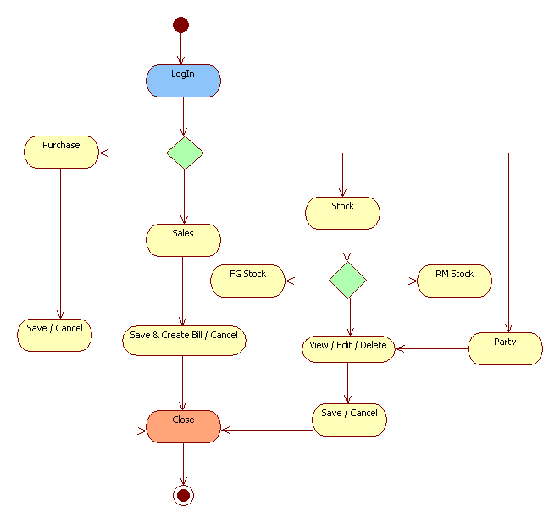

**Class Diagram**

State

-State ID

-State

City

-City ID

-City

-State ID

Party Info

-Company Name

-Tel

-City

-State

-Address

-Website

-E Mail

-Party ID

1 - m

1 - 1

RM Stock

-RM ID

-Coil Thickness

-Coil Width

-Quantity

1 - m

RM Purchase

-Purchase ID

-Coil

-Rate

-Date

-Weight

-Party

1 - m

FG Sales

-Bill No

-Party

-Product

-Quantity

-Rate

-Date

1 - m

1 - m

1 - m

1 - m

1 - m

Owner

-ID

-User Name

-Password

FG Stock

-Product ID

-Product Name

-Quantity

1 - m

**Sequence Diagram**

**SALES**



**PURCHASE**



**State**

**Diagram**

**State Diagram**

Transaction

Logged In

Idle

View/Add/Update/

Delete

Log Out /

Exit

**State Diagram (Transaction)**

Sales Purchase

View the report

Creating the bill

Verification

Verification

Add items to grid

Add items to grid

Connected

Connected

Add the information into the database

Add the information into the database

Disconnected

Disconnected

**State Diagram (View / Add / Update / Delete)**

Stock / Reports / Parties

Fire Query

Get Input

Connected

Disconnected

Show Output

Validate (If Needed)

**System Design**

**Component Diagram**

**Component Diagram**

FG 2

Grip Auto

Spares

Database

ICI

1.6 x 3

Washers

RM 2

1.5 x 2

circlips

FG 1

RM 1

Parties

RM Stock

FG Stock

Purchase

Sales

JK Industries

**Deployment Diagram**

**Deployment Diagram**

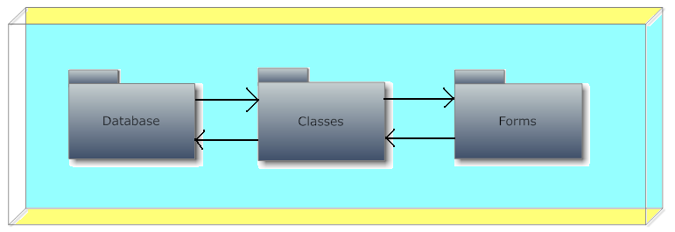

Node

**Structure chart**

**(Program level & System Level)**

**Structure Chart**

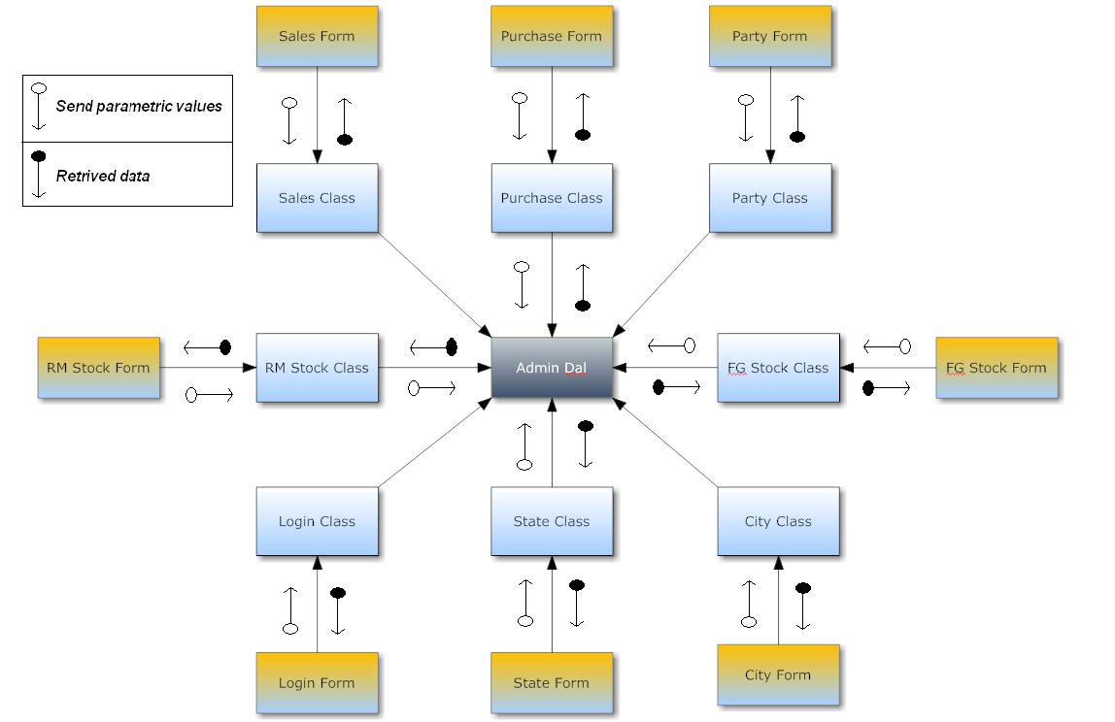

**System Coding**

**MENU-TREE/ SITE-MAP**

**Menu Tree /Site Map**

Grip Auto Spares

File

View

Utilities

Close All

Help

Exit

About Us

Logout

New Purchase

New Sale

Keyboard Shortcuts

Change Password

Notepad

Sidebar

Calculator

Parties

Reports

Stock

Location

**List Of Tables With Attributes And Constraints**

**Database Name:** Grip Auto DB



**Table Structure**

**Table Name:** City



**Table Name:**  State



**Table Name:** FG_Rate



**Table Name:** FG_Sales



**Table Name:** FG_Stock



**Table Name:** Log_In



**Table Name:** Party_Info



**Table Name:** Purchase_Rate



**Table Name:** RM_Purchase



**Table Name:** RM_Stock



**Program Description**

**Validations**

**Validations**

Validations are the technique through which the user comes to know precautions he / she has to take while entering any data

In this project an error symbol  is used to help and block users from entering wrong data

Suppose a user has to enter his name but instead of entering alphabetical characters he/she is entering numbers which is not a valid input. The moment he/she presses a number the error provider symbol will blink beside the textbox which he/she is typing to locate the error. it displays a message saying that type only alphabets.

The error provider even blocks the user from pressing any other key to prevent wrong transactions to happen.

**Screen Layout & Report Layout**

**Test Cases, Test Data, Test Results**

Test case for Party Form

|  |  |  |  |  |
| --- | --- | --- | --- | --- |
| **Test Case** | **Test Data** | **Test Inputs** | **State** | **Test Result** |
| Test Name | ProvideName | Ankit Shetty | Valid | Name is Saved |
| Name not provided |  | Invalid | Please Enter all fields |
| Numbers are entered | Dh65568556 | Invalid | Only Alphabets |
| Test Phone No. | No. is provided | 8898952999 | Valid | Phone No. is saved |
| No. is not provided |  | Invalid | Please Enter all fields |
| Alphabets are entered | 561duifhs |  | Only Numbers |
| Test E-Mail | E Mail provided | Shirva99@gmail.com | Valid | E mail is saved |
| E Mail not provided |  | Invalid | Please Enter all fields |
| Wrong E Mail provided | Jamdfd.com | Invalid | Invalid Email |

Test case for Sales Form

Suppose there are only 300 products in the stock

|  |  |  |  |  |
| --- | --- | --- | --- | --- |
| **Test Case** | **Test Data** | **Test Inputs** | **State** | **Test Result** |
| Quantity | Quantity provided | 200 | Valid | Transaction Done |
| Quantity not provided |  | Invalid | Enter all the fields |
| Quantity provided more than present stock quantity | 1000 | Invalid | Present Quantity=300  Entered Quantity=1000 |
| Negative No. entered | **-**200 | Invalid | Enter numbers greater than zero |

**Screen Layouts & Report Layouts**

**Splash Screen**



**Login Form**

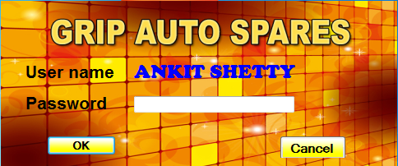

**Main Form**

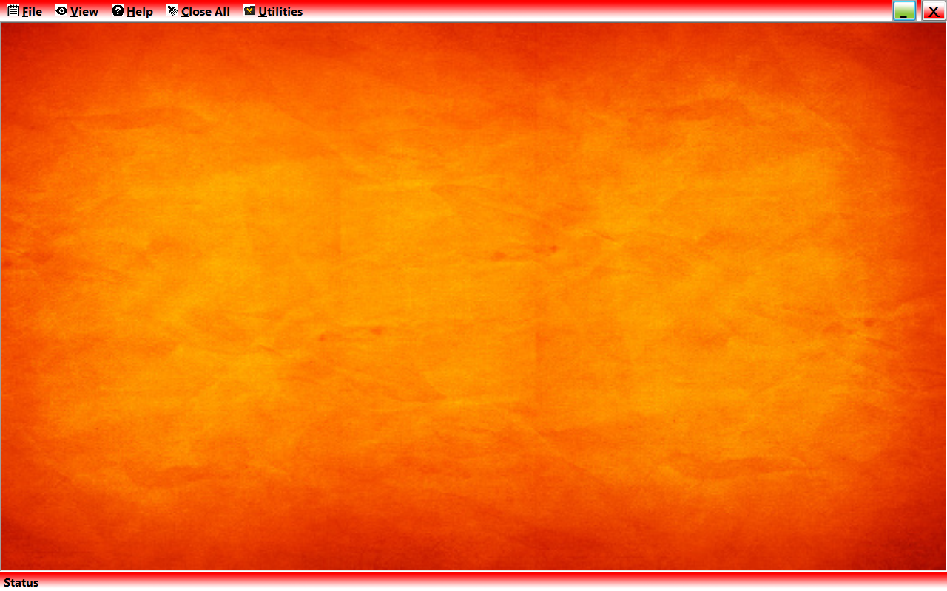

**About Us Form**

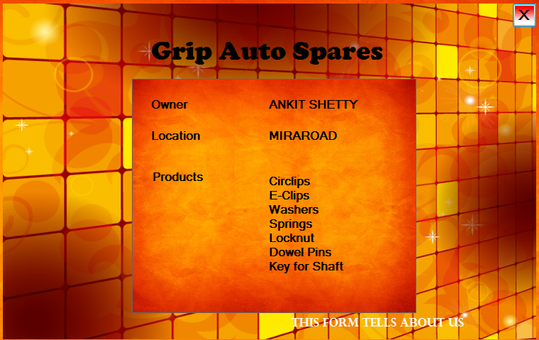

**Change Password Form**

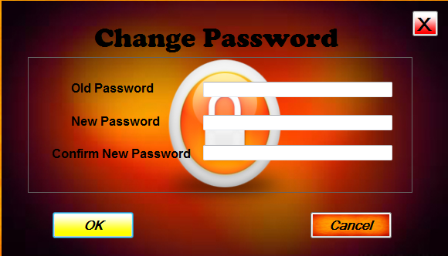

**Finished Goods Stock Form**

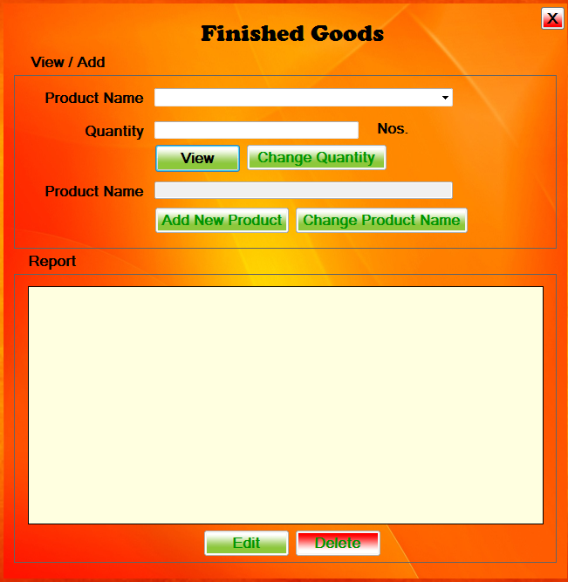

**Raw Material Stock Form**

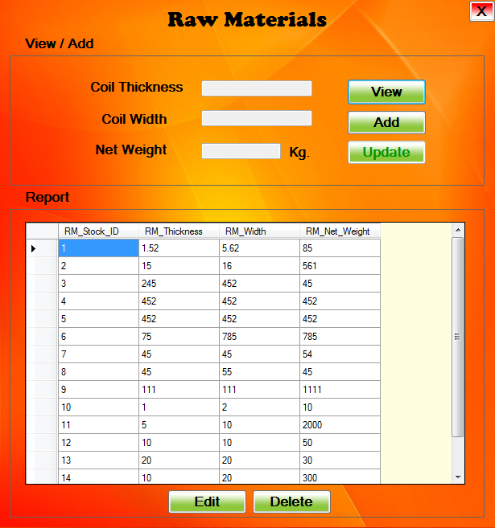

**Party Form**

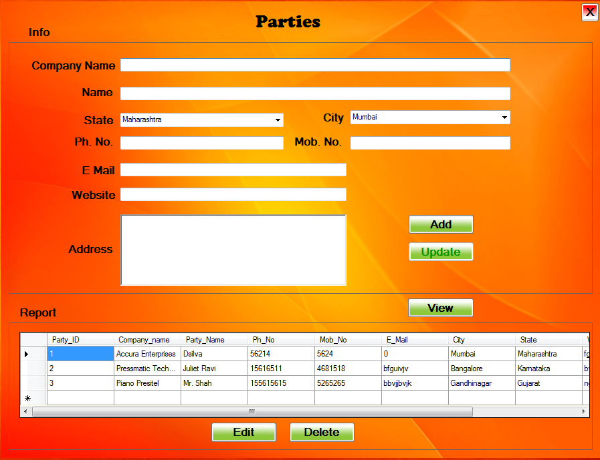

**States Form**

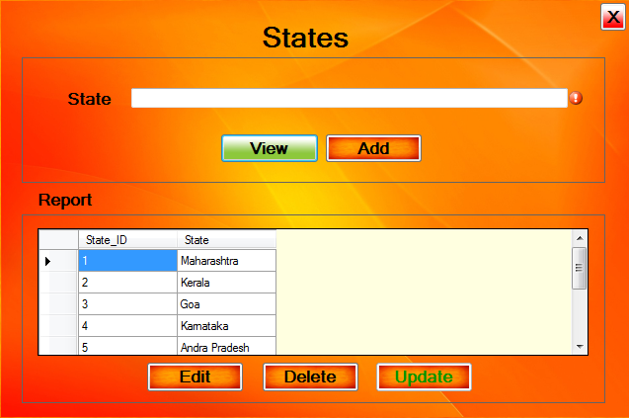

**Cities Form**

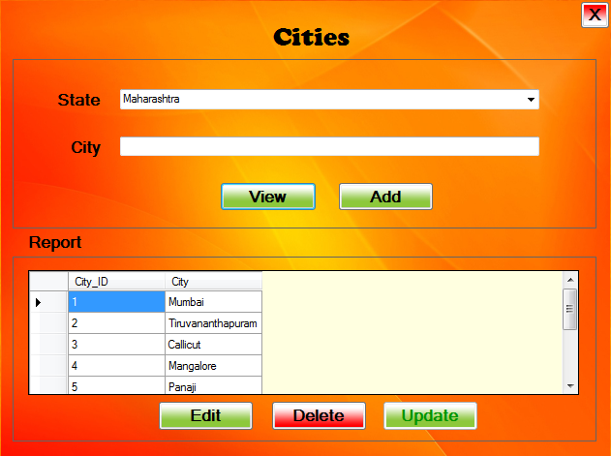

**Sales Form**

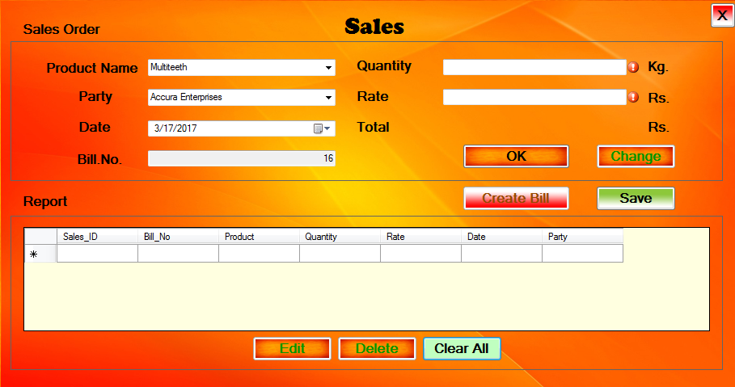

**Purchase Raw Material Form**

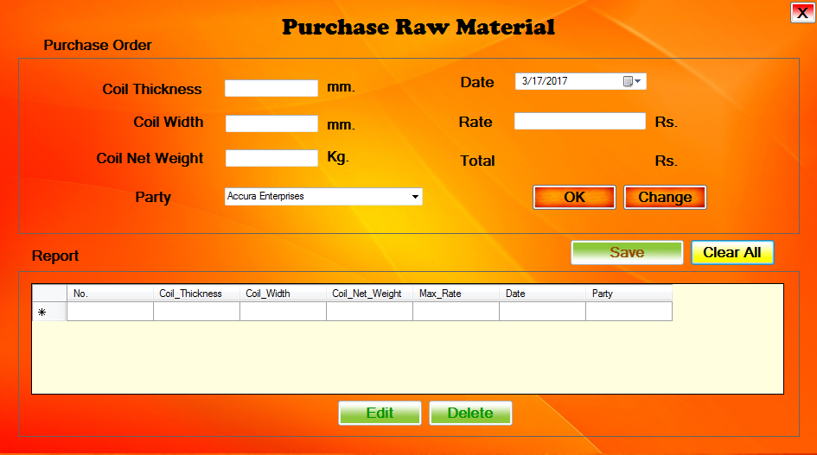

**REPORTS**

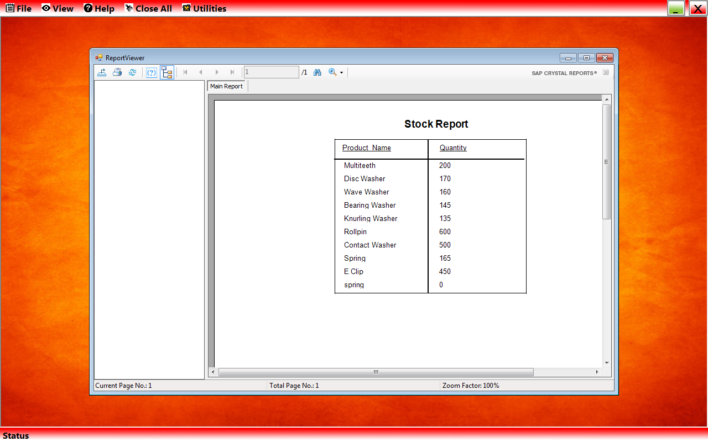

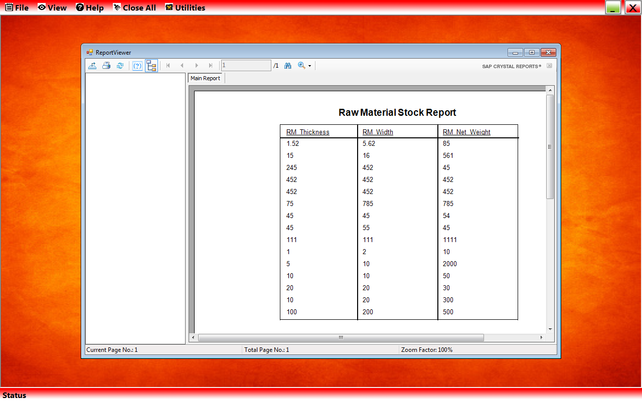

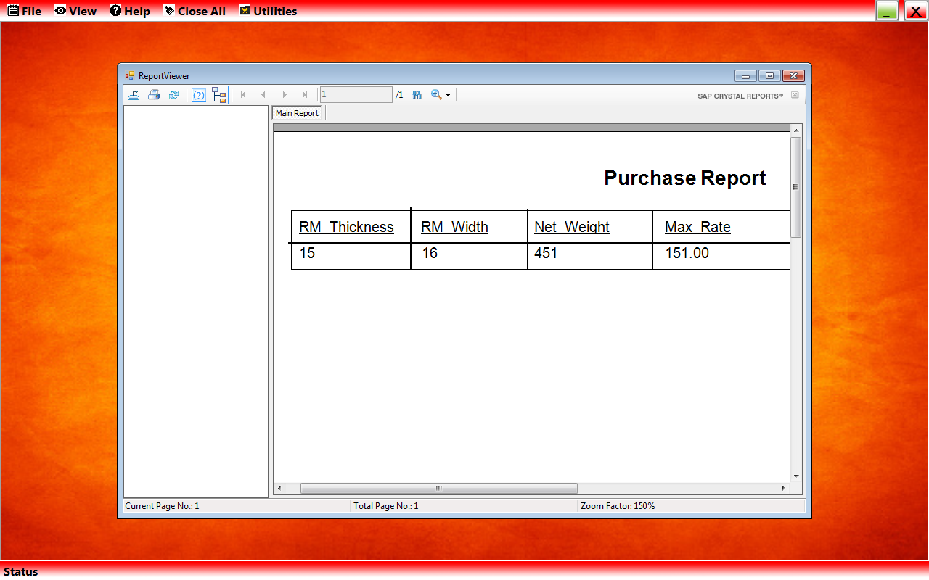

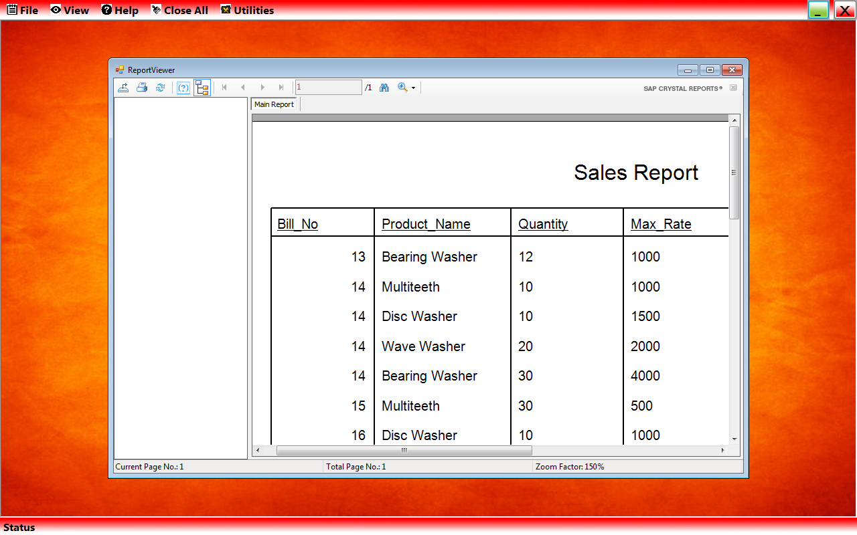

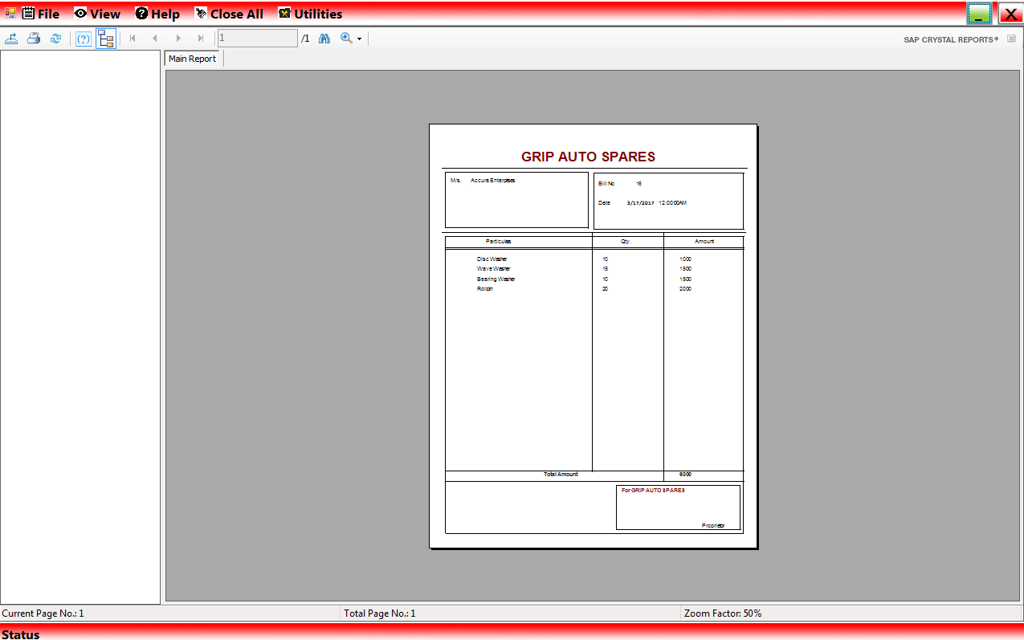

**System**

**Implementation**

**System Implementation**

* the hardware and software system components are installed;
* the selected software is configured and tested;
* the software may be customised to meet local functional requirements;
* data mapping, cleansing and migration take place;
* reporting requirements are specified and reports produced;
* The whole system is tested before being approved, signed off and becoming a fully operational production system.

**Future Enhancements**

**Future Enhancements**

This Software is designed in such a way seeing to it that more components can be added or existing components can be modified easily.

This software is easy to understand even for any fresher developer.

**Reference & Bibliography**

**References and Bibliography**

**Books**

* Visual Studio 2008

**Internet**

* [www.google.com](http://www.google.com)
* [www.wikipedia.com](http://www.wikipedia.com)
* [www.youtube.com](http://www.youtube.com)